FRIENDS OF HOLLINSWOOD & RANDLAY VALLEY

Environmental Officer’s report to FoHRV

Further to the last meeting about the Green Spaces Are Go grant, I’m happy to say that we have purchased 8 benches and they have been placed in positions throughout the Valley and have formed part of the bench-to-bench walks. The funding will also provide a new leaflet, which will show the two identified walks and where the benches are sited with distances.

Volunteer days have been successful with lots of strimming, tree cutting and mowing, We have also welcomed local businesses like Cap Gemini and Denso – their groups have done a fantastic job on the hedgerow to protect the pond, but we are always looking for more local businesses and groups to come into the Valley – their help is much appreciated.

We did have a meeting with Rachel Bates from Smallwoods and she is going make a Woodland Management Plan for us – this will be useful especially as we are now a Local Nature Reserve.

The Ramblers Walks are really struggling to get going. We are doing our best to promote them and encourage more people each month - we have considered altering the dates and times if needed. We also have thought about a WhatsApp group just for this activity.
We are looking at other similar groups to get ideas.

We have also welcomed visitors from TWC, Shropshire Wildlife, RSPB and Idverde and we will soon be receiving various reports and data relating to the Sites of Specific interest (SSI) within the Valley.

Richard Shaw and I had meeting in the Valley about the bridleway and the accessibility of it and he is going to ask a contactor to cut the big trees. However, he did mention that the other trees would need to be removed by volunteers. Having talked about the number of volunteers we have and how much work needs to be done at the bridleway, he is going to try to arrange for some local business to join us to tackle this area together. I have shared the volunteer days with him. Also, Rachel Bates has mentioned installing a few leaky dams. She was thinking of W8 Section and W4. This will need further consideration (and access to funding)
Please take a look at the map below.

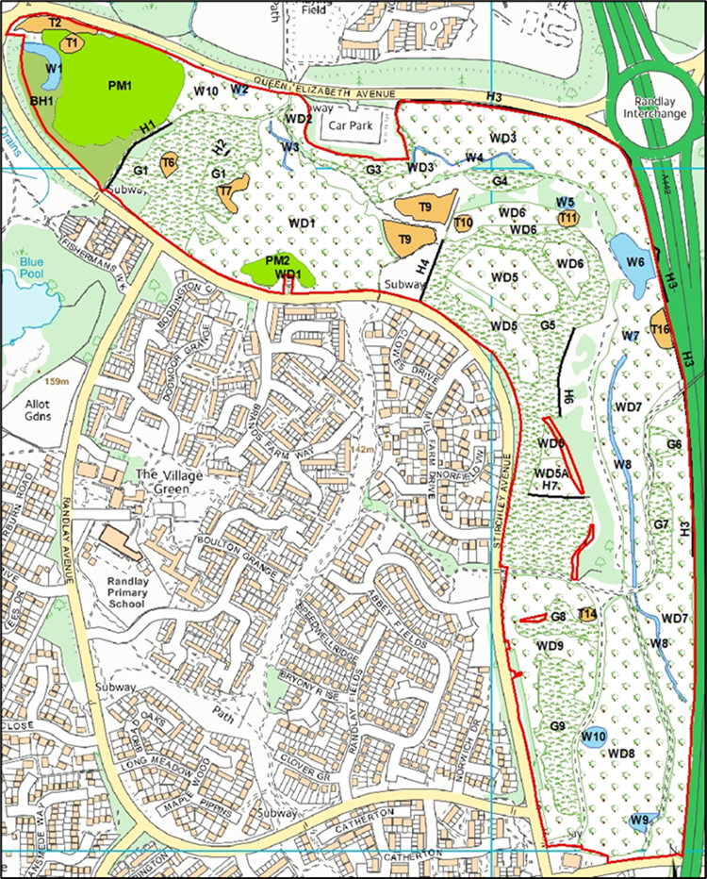

Liam Seabury
Environmental Officer
Friends of Hollinswood & Randlay Valley

